What is NHS Continuing Healthcare?

Written by:

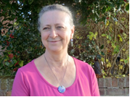

Alison Giraud-Saunders

Su Fitzgerald

What is this book about?

This book is about money from the NHS to pay for help and care.

This is called NHS Continuing Healthcare.

This book is for people with learning disabilities, family carers and anyone who helps a person with learning disabilities.

You can look at the book on your own.

Or you can ask someone to look at the book with you and talk about what it says.

There is a list of hard words at the back of the book to tell you what each word means.

Who helped?

Denise Gentry, Clinical Nurse Specialist, South West London and St George’s Mental Health NHS Trust
John Burley, User Involvement Co-ordinator, Leeds and York Partnership NHS Foundation Trust, with the Leeds Learning Disability Reference Group and members of the Your Health Matters Project
Anna Fedeczko, Senior Quality Officer, Manchester Learning Disability Partnership
Debbie Firth, Continuing Healthcare Facilitator, Manchester Learning Disability Partnership
Kingston Easy Information Group
Jim Ledwidge, Trish O’Gorman and Karen Scarsbrook on behalf of the National Policy Advisory Group for NHS Continuing Healthcare
Manchester People First
Personal Health Budgets team, NHS England
Lynne Richardson and Dianne Shires, CHC Co-ordinators, Leeds and York Partnership NHS Foundation Trust
Gary Watt, Learning Disability Continuing Care Nurse Assessor, Greater East Midlands Commissioning Support Unit
Laura Whiteman, Highly Specialist Speech and Language Therapist, Your Healthcare CIC
Sharon Wood, Strategic Health Facilitator, Nene Clinical Commissioning Group

Alison Giraud-Saunders is an independent consultant who works to make health services better for people with learning disabilities.

Su Fitzgerald is the Adult Safeguarding Lead for Your Healthcare CIC.

Special thanks to Denise, Laura and the Kingston Easy Information Group for all their help.

The Department of Health gave the money for the book. Thank you!

What is in this book?

 |  | Page
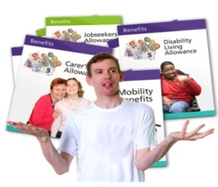 | What is NHS Continuing Healthcare? | 8
 | Who can get NHS Continuing Healthcare? | 11
 | Who will help you find out about NHS Continuing Healthcare? | 13
 | What will happen at each step? | 15
 | Step 1: Checklist | 16
 | Step 2: The big assessment | 19
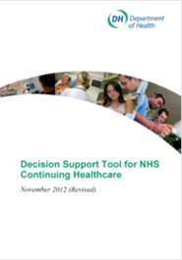 | Step 3: Agreeing what is written about you | 23
 | Step 4: Decision about the money | 24
 | Step 5: Your health money and how to use it | 26
 | Step 6: The help you will get | 32
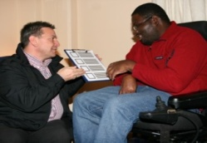 | Step 7: Finding out if all your help and care is working | 34
 | Other things you should know | 36
 | Useful things to look at | 39
 | List of hard words and what they mean | 43

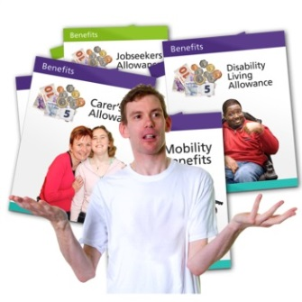

What is NHS Continuing Healthcare?

 | NHS Continuing Healthcare pays for help and care.
Social services | Most people have their help and care paid for by social services (the council).
 | People who need a lot of help because of their health may get NHS Continuing Healthcare.
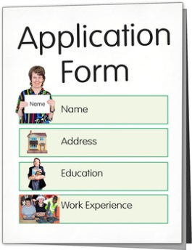 | You might have help with some or all of these things:  - a place to live – home!  - help at home  - help with travelling  - help with a job or other things to do in the day  - help to do things that are fun, like seeing friends or going to see a play  - help to look after someone else (being a carer).
After 1 April 2014 you can ask to have NHS Continuing Healthcare as a Personal Health Budget.

Find out more about this on page 28.

A Personal Health Budget is when the NHS tells you how much money there is for your help and care. You agree with the NHS how the money will be spent.

Who can get NHS Continuing Healthcare?

 | NHS Continuing Healthcare is for people who need a lot of help because of their health.
Some people need help because they have difficulty with things like:
- breathing
- eating and drinking
- taking medicines
- moving about
- memory and thinking.

 | If you need help with some of these difficulties NHS Continuing Healthcare might be for you.
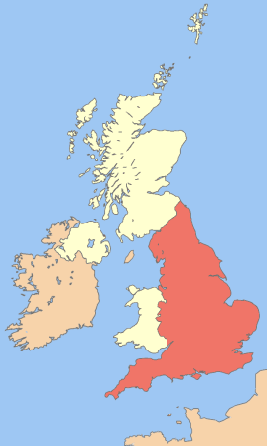 | It does not matter where you live in England.  It does not matter whether you live on your own or with other people.
If you are a carer you might want to find out if the person you care for should get NHS Continuing Healthcare.

You can use the information in this book for yourself or other people.

Who will help you find out about NHS Continuing Healthcare?

You or your family can ask about NHS Continuing Healthcare. You can ask:
- your social worker
- your family doctor
- a nurse or another health worker.

 | It is a good idea to ask questions about NHS Continuing Healthcare. You can ask questions like these:
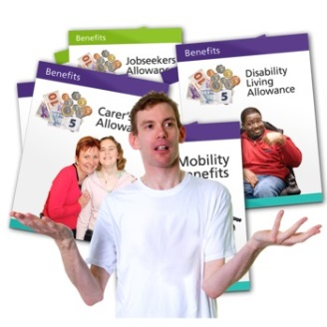 | - Who decides about NHS Continuing Healthcare in my area?  - Can I have NHS Continuing Healthcare as a Personal Health Budget?  - Can I have NHS Continuing Healthcare as a direct payment?  - Does NHS Continuing Healthcare make a difference to my benefits?
 | Do you have other questions?
 | If you are very ill and need a lot of help in a hurry a doctor can decide to give you NHS Continuing Healthcare straight away. This is called Fast Track.
 | Now go to Step 1 to see what happens next....

A direct payment is when you are given money to pay for your help and care. You control the money.

What will happen at each step?

There are 7 steps.

Read on to find out about each step.

Step 1: Checklist

A social care worker or a health worker like a nurse will come and see you.

This might be part of your usual review meeting.
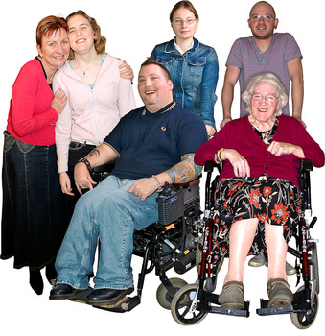 | You can have a member of your family, a friend or advocate to help you.  You can ask about having an advocate if you do not have one
The worker will ask if it is OK to ask you questions.

They will ask about your health and the help you need.

You can show them your person centred plan and other plans.

 | They will want to talk to your family or other people who support you. They will check if this is OK.
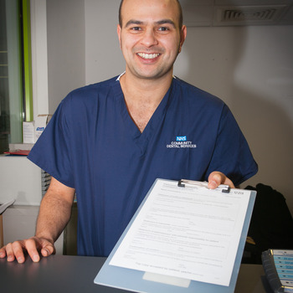 | They may talk to other people who know you, like your doctor, nurse, social worker or other staff from the community team.  They will want to look at the information those people keep about you.
 | They will fill in a form called a Checklist. You can ask for a copy.
 | They will ask you if you have any questions.
Step 2  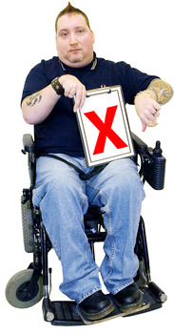 | They will use the Checklist to decide if you do or do not go on to Step 2.

Step 2: The big assessment

Step 1 Step 2 | If you go on from Step 1, this is what happens next.
A health worker like a nurse will come and see you.

They might bring someone else with them like a social worker or another health worker.

They might come more than once.
 | They can come and see you at home or somewhere else if you prefer.
 | You can have someone with you – like a member of your family, a friend or advocate.
The health worker will ask you if it is OK to ask you more questions.

They will ask more questions about your health and the help you need.

 | You can show them your person centred plan and other plans.
 | They will want to talk to your family and other people who support you. They will check if this is OK.
 | They will ask if it is OK to talk to other people who know you, like your doctor, nurse, social worker or other staff from the community team.
 | They will want to look at the information those people keep about you.
 | The health worker might get everyone together for a big meeting.
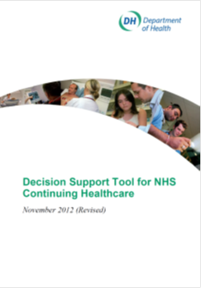 | They will fill in a big form called the Decision Support Tool.
 | They will ask you if you have any questions.

Step 3: Agreeing what is written about you

When the health worker has collected all the information they need they will write about what they have seen and heard.

They will ask you and your family or advocate if you agree with what they have said.

If you do not agree you can say so. They will write down what you say about why you disagree.

Step 4: Decision about the money

Panel | The health worker will go to your local NHS Clinical Commissioning Group. In your area this might be called the “panel”. The health worker will ask them to decide if you will get NHS Continuing Healthcare.
They will use all the information the health worker collected about you.

They will tell you what they decide.

Check Again | If the NHS Clinical Commissioning Group says ‘No’ and you are not happy with that you can say so. You can ask them to look at all the information again.
Social Services | If you do not get NHS Continuing Healthcare sometimes the NHS will agree with social services (the council) that they will pay together for the help you need. This is called joint funding.
If the NHS Clinical Commissioning Group says ‘Yes’ they will choose someone to work with you.

They might be called:
- a Case Manager
- a Care Manager
- a Community Nurse.

Step 5 | Now go to Step 5.

The NHS Clinical Commissioning Group for your area is the group that decides about most health services in your area. They decide how to spend NHS money.

Step 5: Your health money and
how to use it

NHS Continuing Healthcare money is for all your help and care, not just health care.

It is important to make sure the plan for the money is about all your help and care.

If you are getting support or money from social services (the council) this will change over to NHS Continuing Healthcare. Sometimes social services go on giving some help too.

If you get NHS Continuing Healthcare there are different ways you can have it. These are on the next page.

A. You can ask for a Personal Health Budget. Read more about this on pages 28 to 30.

Or

B. You can let your local NHS Clinical Commissioning Group and your worker decide about your help and care. Read more about this on page 31.

A. You can ask for a Personal Health Budget

A Personal Health Budget is like a Personal Budget from social services (the council), but the money comes from the NHS.

After 1 April 2014 you have the right to ask for NHS Continuing Healthcare as a Personal Health Budget.

After 1 October 2014 you have the right to have NHS Continuing Healthcare as a Personal Health Budget.

A Personal Budget is when social services (the council) tell you how much money there is for your help and care. You agree with them how it will be used.

There are 3 ways you can have a Personal Health Budget:

1. Budget (money) held by the NHS.

The NHS tells you how much money there is for your help and care.

You say how you want the NHS to spend the money

2. Budget (money) held by someone else.

The NHS tells you how much money there is for your help and care.

An organisation, like a charity or a support service, looks after the money for you. They help you decide how you want to spend it.

3. Direct payment

The NHS gives you the money to buy and manage your own help and care.

You can ask for a copy of the easy read book about Personal Health Budgets if you would like to know more.

Personal Health Budgets are quite new, so some people do not know very much about them yet.

You can use this book to say if you want a Personal Health Budget!

B. You can let your local NHS Clinical Commissioning Group and your worker decide about your help and care.

The NHS Clinical Commissioning Group could offer you help at home. They might pay support workers or nurses to do this.

Or they might offer you a place in a care home. Some people want this.

Step 6: The help you will get

 | You may have a person centred plan already. You may have a Health Action Plan or recovery plan too.
 | You may want to look at all your plans again when you know how much money you will have for your help and care.
 | You might decide all your help is just fine! You can talk to your health worker about using NHS Continuing Healthcare to go on with the help you have now.
 | You might want to make some changes in your help. You can talk to your health worker about using NHS Continuing Healthcare to get the new kinds of help you need.
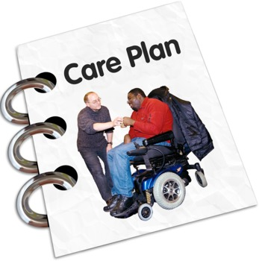 | Your support plan should say how NHS Continuing Healthcare will help you live your life.  Remember - this is about all your help and not just health care.

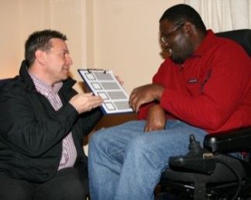
Step 7: Finding out if all your help and care is working

After 3 months the health worker will check if you still need NHS Continuing Healthcare.

Then they will check every year.

The health worker will check how you are getting on.

You can talk to them if you need some changes in your help and care.

You can look at your support plan (from Step 6) and make sure it is still right for you.

Other things you should know

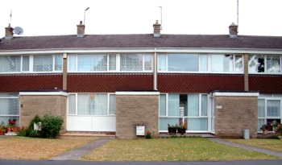 | It does not matter where you live.  NHS Continuing Healthcare can pay for your help at home or in a care home.
Your health worker must listen to what you want and write this down.

You might have to explain very carefully what is right for you and why.

Your help can stay the same unless there is a good reason to change.
If you get Independent Living Fund money this will stop once you get NHS Continuing Healthcare.

NHS Continuing Healthcare is instead of money from the Independent Living Fund.

If you live at home your benefits should not change.

If you live in a care home some of your benefits might stop.

NHS Continuing Healthcare is instead of some benefits in a care home.

If you do not want NHS Continuing Healthcare you can ask the NHS to look again at the form with all your information (Steps 2 and 3).

This is not easy. If the NHS says you should have NHS Continuing Healthcare then social services (the council) will not pay for your help and care.

If you are not happy with your support plan you can ask for it to be looked at again.

Ask your worker how to do this.

Useful things to look at

1. Easy read information

Health and health care

Easy Health website http://www.easyhealth.org.uk/

Planning your support

Foundation for People with Learning Disabilities website http://www.learningdisabilities.org.uk/publications/personal-planning-book/

Personal Health Budgets

Easy read Personal Health Budgets book http://www.personalhealthbudgets.england.nhs.uk/About/Publications/?&msg=0&excludepageid=2289&parent=8077&child=5794

The website is not easy read but you can get the easy read guide there
Making decisions

Easy read book about the Mental Capacity Act http://www.justice.gov.uk/protecting-the-vulnerable/mental-capacity-act

The website is not easy read but you can get the easy read guide there

2. Information that is not easy read

Information for families about NHS Continuing Healthcare

‘What do I need to know about NHS Continuing Healthcare?’
http://www.learningdisabilities.org.uk/publications/continuing-healthcare/

Information from the Department of Health about NHS Continuing Healthcare

https://www.gov.uk/government/publications/national-framework-for-nhs-continuing-healthcare-and-nhs-funded-nursing-care

Information about Personal Health Budgets

Personal Health Budgets website http://www.personalhealthbudgets.england.nhs.uk/About/faqs/

This includes a guide on making Personal Health Budgets available to people with learning disabilities.

peoplehub peer support network http://www.peoplehub.org.uk/

inControl series of factsheets on self directed support, including one on Personal Health Budgets http://www.in-control.org.uk/resources/fact-sheets.aspx

Information about the Mental Capacity Act

Pack for family carers http://www.hft.org.uk/supporting-people/family-carers/resources/mca-guide/

Information about planning support

Website with resources (including some easier read) and links http://www.supportplanning.org/LearningD/

Think Local Act Personal website http://www.thinklocalactpersonal.org.uk/Browse/tags/index.cfm?tag=support%20planning&orderBy=date&page=1

Making health information easy read

Easy on the i website https://easyonthei.worldsecuresystems.com/easy-on-the-i.html

A Picture of Health website http://www.apictureofhealth.southwest.nhs.uk/

Note: We checked all the website links in February 2014

List of hard words and what they mean

Checklist | The name of the form that is filled in by the worker who asks questions to see if you should have a big assessment for NHS Continuing Healthcare.
Decision Support Tool | The name of the form that is used by the nurse or other health worker who does the big assessment to see if you should get NHS Continuing Healthcare.
Direct payment | A direct payment is when you are given money to pay for your help and care. You control the money.
NHS Clinical Commissioning Group | This is the group that decides about most health services in your area. They decide how to spend NHS money.

NHS Continuing Healthcare | NHS Continuing Healthcare pays for help and care for people who need a lot of help because of their health.
Personal Budget | A Personal Budget is when social services (the council) tell you how much money there is for your help and care. You agree with them how it will be used.
Personal Health Budget | A Personal Health Budget is when the NHS tells you how much money there is for your help and care. You agree with the NHS how the money will be used.

