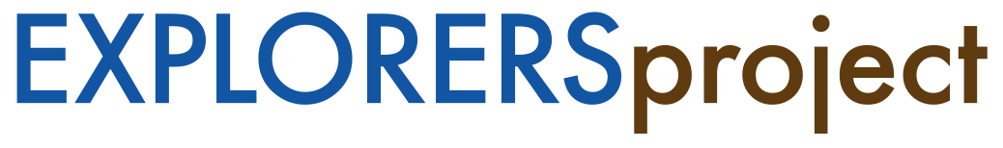
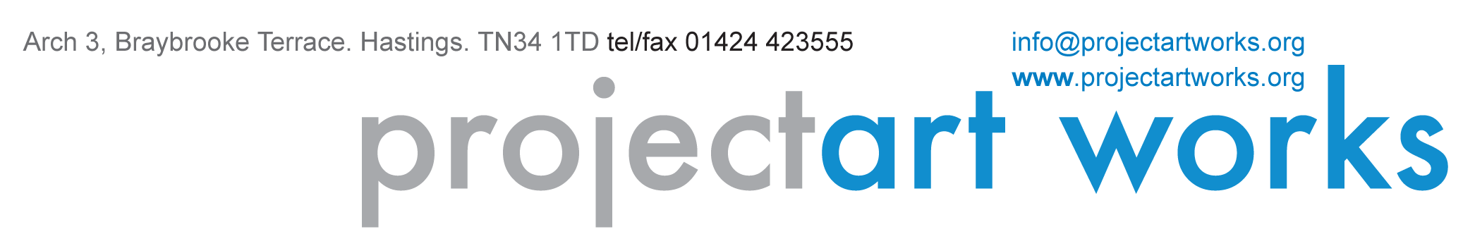
EVALUATION BRIEF

EXPLORERS Project Art Works

PROJECT ART WORKS
Based in Hastings, Project Art Works is the UK’s leading artist led organisation working with children, young people and adults with complex and additional needs and their families, carers and circles of support. The people who have shaped the organisation share a purpose, which is not to do ‘good works’ but to pursue a vital enquiry: to find out what someone is capable of and to explore with them the possibilities of art through collaborations that foster choice, subjective preference, intuition and non-verbal interaction.

In a social and political landscape that is constantly shifting, our work seeks to address areas of need as they occur. Our artistic approach is as much about our ability to affect positive change in society, as it is to produce artifacts. The activities we provide are: 1:1 creative workshops, group participatory workshops, ongoing creative collaborations with associates who have complex needs, professional development, support for whole families, advocacy and advice and interventions to improve care outcomes.

The Project Art Works team have extensive expertise in specialised systems of support such as Personalisation, Total Communication, Positive Behaviour Support and the complex statutory systems for accessing this support. Our specialist artists work intensively with participants on a 1:1 basis supporting them to engage with materials and creative processes and access a place of freedom and purpose not dictated by their disabilities. This expertise combines to form a hugely successful approach to making art in collaboration with children, young people and adults who have complex needs that is of exceptional quality.

PROJECT OUTLINE
EXPLORERS - Illuminating the Wilderness is an innovative programme of art and discourse that will challenge perceptions through creating supportive and deeply affecting interactions between neurotypical and non-neurotypical collaborators. The EXPLORERS programme will positively increase public, artists’ and arts professionals’ awareness of the extraordinary contribution people with complex needs can make to mainstream culture and will position them as leaders.

EXPLORERS is a three-year programme of holistic, collaborative work that will deliver six co-commissioned exhibitions and installations to form a ‘festival of cultural inclusion’ in 2019. The artworks will emerge from relevant, creative and meaningful engagement with neurodiverse communities placing the discourse of inclusion at the centre of mainstream exhibition spaces and programmes in England and Sydney, Australia.

The inherent awareness raising and discourses in EXPLORERS will open up greater understanding of the
relevance to art and culture of diverse states of being. Different ways of perceiving and interacting with the world
provide rich territories for creative programming and new art.

The EXPLORERS partnership of 12 national and international organisations has been selected for their individual expertise and their openness to change and socially connected practice that is necessary to provide a legacy of cultural producers highly experienced in inclusion and neurodiversity. All partners are established leaders in audience development and digital work. Partners include:

1. Tate Liverpool www.tate.org.uk
2. The Forestry Commission www.forestry.gov.uk
3. MK Gallery www.mkgallery.org
4. Autograph ABP www.autograph-abp.co.uk
5. Fabrica www.fabrica.org.uk
6. Photoworks www.photoworks.org.uk
7. UNSW, National Institute for Experimental Arts, Sydney, Australia www.niea.unsw.edu.au
8. South East Museum Development Programme www.southeastmuseums.org
9. Artswork SE Bridge www.artswork.org.uk
10. De La Warr Pavilion www.dlwp.com
11. Hastings Borough Council
12. East Sussex County Council

This project embraces the needs of participants and makers in EXPLORERS who may not be able to knowingly consent to their involvement in the project and its different participatory events as well as outputs like films, photography etc. In order to monitor and work with individual needs to ascertain consent we follow some of the following approaches:
• talking to individuals and their families/support teams about how to involve them
- monitoring ascent/dissent towards participation and ascertaining consent from these observations
- providing choice in participation – if an individual needs or wants to leave the Studio and/or event they have
the support to do so
- ensuring flexibility in approaches to making work and to different studio/exhibition environments.
- monitoring responses moment by moment. If an environment, activity or interaction feels unsuitable we
make changes to this
- building trusting relationships with individuals and their circles of their support that provide insight into the
ways they interact and communicate and how to positively respond to this.

WORK OUTLINE
Project Art Works will create a comprehensive programme of working with project partners, neurodiverse people and their families and the systems of support that impact on their lives including health and social care agencies, support workers, care managers and community learning disability teams. Case studies, models of best practice, new training methods and learning will be shared with cultural and social care sectors and people with complex needs and their carers, cultural organisations and public audiences in digital and printed formats. This will be achieved through:
• Mapping social care sectors (local, regional, national)
• Building connections between galleries, museums, social care and health commissioners
• Working collaboratively with people with complex needs within each geographical area, locally and
nationally
• Supporting and delivering creative actions and ‘encounter’ events that facilitate real & lasting connections
between people with complex needs and the cultural sector.
• Establishing methodologies with each partner that open up cultural venues as places for support and
sanctuary for people with complex needs, their families & carers by using venues for peer networking and
support.
• Promoting cultural venues as centres of wellbeing
• Providing models of peer support networks for families and carers of people with complex needs in
particular for young people in transition.

A project website will document the process and outcomes of the project that can be shared with new
organisations. This will include a minimum of three short films that document the process and five short films that share the artistic process of the co commissions. It will also be a site that will bring together reports, evaluations, tool-boxes and information to reach a wider number of cultural organisations.

This programme of exhibitions and events will be celebrated through a joint publication produced by Project Art Works. We will appoint an editor at an early stage of the programme to:
• support the structure and concept development of the publication
• establish a way of working across multiple partners and contributors
• ensure all aspects of the creative productions and co-commissions are covered

EXPLORERS will:
1) Provide the cultural sector with the resources and skills to deliver on the Creative Case and the
opportunity to widen their sources of funding
2) Co-commissions – Project Art Works will deliver a new mentoring approach to enable organisations to own the development and implementation of inclusive commissions with new artists as part of their main artistic and
curatorial programmes
3) Scale – Project Art Works has not as yet delivered such a coherent and ambitious programme of collaborations and outreach with multiple partners over time. EXPLORERS will reach more than 160 neurodiverse individuals and their communities of support across the UK and in Australia and thousands of new audiences.
4) Discourse – Opening up a pulse of conversations to fully and candidly explore the barriers to inclusion
and responses to cultural inclusion. This is essential to the success of the programme, its artistic outputs and
wider impact
5) International presence and profile – taking a methodology to a new cultural and social care audience
6) Scale of artistic ambition for the overarching creative production and outdoor exhibition of EXPLORERS at Tate Liverpool and in a forest site in 2019

EVALUATION

Purpose of evaluation:
Project Art Works has a strong and innovative approach to evaluation and inclusive methodologies for gathering feedback from people who may not be able to knowingly consent or contribute to evaluative processes. However, their contribution is extremely important within EXPLORERS in all ways. Project Art Works ACE and all partners/collaborators want to understand the impact of the project as well as to discover more about attitudes and barriers to cultural inclusion and what EXPLORERS may do to change this?

EXPLORERS is breaking new territory within the cultural sector in that the programme challenges curatorial and programming within contemporary visual art. All partners have a strong commitment to the work and this bodes well for a full and exploratory approach to evaluation. Possible areas for evaluative focus are:
- the barriers to cultural inclusion?
- understanding of the term cultural inclusion?
- how receptive public audiences are to diversity & cultural inclusion?
- what all collaborators learn through their involvement in EXPLORERS?
- what aspects of the work will cultural partners take forward?
- what will partners within the social care sector take from the programme?

As part of the evaluation process the evaluator will work closely with a member of Project Art Works’ staff to support the process. In consultation with the partners we need to agree and define:
- What we will be evaluating
- Identify roles
- Establishing what the partners want to achieve from their involvement in the project
- Evaluation structure and timetable
- Inclusive methodologies (including video, social media, sound recordings, interviews, questionnaires).

Fee for freelance contract: £15,000 including VAT and expenses.

Timescale:

June 2017 – January 2020

Deadline for final report
17 January 2020

Application deadline (new extended deadline): Wednesday 17 May 2017, 9am
Please email your proposal, 2 sides of A4 maximum plus the completed Equal Opportunities form, with EXPLORERS Evaluator in the subject to:
Lisa Finch, Lead Programmes & Development
lisa@projectartworks.org

Interviews: Thursday 1 June 2017 at Project Art Works, Hastings.

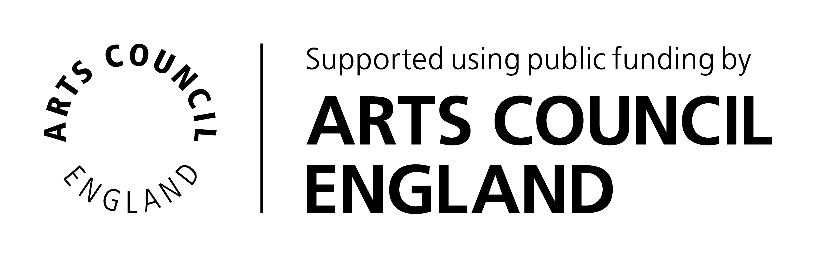

MONITORING FORM

This form is for monitoring purposes only. It will be detached from your application and does not form part of the recruitment process. We are asking for this information to ensure that when recruiting we are attracting a diverse range of people as possible.

For each section there is an option ‘I choose not to answer’ if you are uncomfortable answering any or all of the questions, please tick this box rather than leave the section blank as we can still capture your reply as a valid statistical response. All data collected from this form will be held securely and confidentially. Thank you.

Age

16 - 25 years ☐ | 46 - 55 years ☐
26 - 35 years ☐ | 56+ ☐
36 - 45 years ☐ | I choose not to answer ☐

Gender

Male ☐ | Female ☐ | I choose not to answer ☐

Do you consider yourself to be a disabled person, have a long-term health condition or have any access needs?

No ☐ | Yes ☐ | I choose not to answer ☐

Are you ‘statemented’ as dyslexic?

No ☐ | Yes ☐ | I choose not to answer ☐

Please tick the box that applies to your background

White: British ☐ | Asian or British Asian: Indian ☐
Irish ☐ | Bangledeshi ☐
Any other White background (please give details) ☐ | Pakistani ☐
 | Any other Asian background (please give details) ☐
Mixed: White & Black Caribbean ☐
White & Black African ☐ | Black or Black British: Caribbean ☐
Any other Mixed background (please give details) ☐ | Africa ☐
 | Any other Black background (please give details) ☐
Chinese or any other ethnic group:
Chinese ☐ | Any other (please give details) ☐
I choose not to answer ☐

